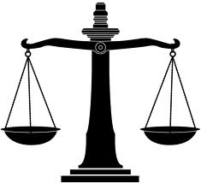Justice at home and overseas(Revision)

KEY WORDS/TERMS

|  |  |  |
| --- | --- | --- |
| Word/Term | Definition | Examples |
| Bicameral |  |  |
| Legislation |  |  |
| Constitution |  |  |
| Constitutional monarchy |  |  |
| Referendum |  |  |
| Ratify/Ratified |  |  |
| Global citizen |  |  |
| Word/Term | Definition | Examples |
| Refugees |  |  |
| Resolutions |  |  |
| Governance |  |  |
| Convention |  |  |
| Asylum seeker |  |  |
| Foreign Aid |  |  |
| High Court |  |  |
| Treaty  (International agreement) |  |  |